|  |  |
| --- | --- |
|  |  |

**2013 Benchmark Message Testing of Key Opinion Leaders Executive Summary**

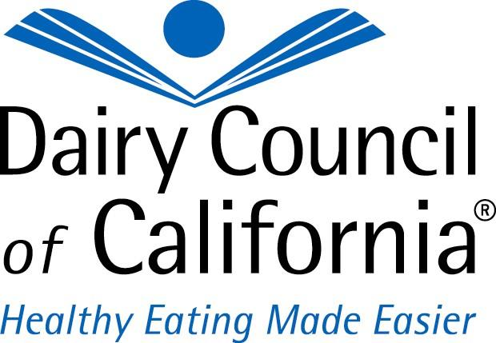

**Overview**

* In the summer of 2012, the Center for Food Integrity (CFI) tested three revised key milk messages for agreement with consumers. The results were as follows:

1. Consuming milk and milk products is essential to a healthy diet (46% agree).
2. Scientific research confirms the many health benefits that milk and milk products provide (45% agree).
3. Milk and milk products have an irreplaceable package of nutrients that cannot be found in any other single food or beverage (33% agree).

* The researchers found that the messages were clearly understood and results showed there was room for improvement. Since the Dairy Council of California® works through Opinion Leaders to reach consumers, the D.C.C. management team determined that in order to accurately assess how their strategies and tactics were positively impacting beliefs about milk’s role in a healthy diet, that the D.C.C. would need message benchmark testing of California Opinion Leaders in the health and nutrition environment.
* The Dairy Council of California® requested a telephone market research study to evaluate the three potential message platforms.
* The telephone research involved interviewing 100 Opinion Leaders from a list of 162 individuals and organizations provided by the Dairy Council of California®.
* At no time was the Dairy Council of California® identified as the sponsor of the research nor was its name used at any time during the interviewing.
* All of the three messages evaluated in the survey were rotated on a random probability basis throughout the questionnaire to avoid any potential order bias. The random rotation was accomplished using MEG’s CATI system and is not reflected in many cases in the Word file of the questionnaire.
* An important consideration is that the research measures Opinion Leader perceptions. Perceptions can be factually incorrect; but they are never wrong and are more important to opinion leader decisions and actions than the “facts.”
* When viewing the Opinion Leader data, statistical caution should be used because of the small universe and number of interviews. In that regard, the data should be used as more of a census than based on sampling error.
  + Of the 162 Opinion Leader names and organizations provided by the Dairy Council of California®, MEG contacted 76.5% (124) of the sample universe.
  + Among survey respondents contacted, the research achieved a completion rate of 80.6% (detailed call statistics are provided on page two of the Survey Tabulations and Statistics).
* A full detailed report, a statistical analysis, call statistics, Excel files used to create PowerPoint charts, and the questionnaire used in the research are available separately. A data file and code book are also available.

**Recommendation**

* Of the three messages that the Dairy Council of California® tested, the data strongly supports a recommendation for using (among the three evaluated): “Consuming milk and milk products is essential to a healthy diet.”
* “Consuming milk and milk products is essential to a healthy diet” is the recommended message because:
  + It is the most preferred message with 65 of the 100 survey respondents.
  + It is mentioned the fewest number of times (10) as being the least preferred message.
  + It has the highest ratio of unaided favorable comments to unaided negative comments of the three messages.
  + It is the highest rated message by a wide margin based on both mean and median scores on all of the six aided attributes included in the research.

**Rating the Three Potential Messages**

* The survey asked Opinion Leaders to rate each of the three messages on a 10-point scale (10 is highest, one is lowest) on six variables:

1. Believability
2. Effectiveness
3. Importance
4. Likelihood to encourage people to seek more information and resources about healthy eating and nutrition related to milk and milk products
5. Overall opinion
6. Likelihood of you using each of the three messages in your own work

* When looking at the results of a 10-point Lickert scale, the distribution of the results are important. Respondents who give ratings of four to seven are unlikely to take action or make decisions because their beliefs or attitudes are not strongly held. Instead, Opinion Leaders, like most survey respondents, make decisions and take actions based on the opposite ends of the continuum (i.e., ratings of one to three or eight to 10).
* “Consuming milk and milk products is essential to a healthy diet” received the highest mean and median scores by a wide margin on each of these six variables.
  + Of a greater importance, its median scores on all six variables was either an eight or a nine, meaning Opinion Leaders responses are skewed to the very highest and most positive end of the 10-point scale. Median scores in the eight and above range are likely to lead to a favorable communications outcome.
* In contrast, the two messages “Milk and milk products have an irreplaceable package of nutrients that cannot be found in any other single food or beverage” and “Scientific research confirms the many health benefits that milk and milk products provide” get median scores on all six variables of a five or six – scores unlikely to typically lead to positive action or decisions.
  + Of greater unease, is the representation of their scores in the one to three range – these are likely to lead to adverse actions and are reflected in the greater number of dislikes about the two statements than positive ones.

**Most Appealing and Least Appealing Aspects of Each Message**

* Opinion leaders were asked on an unaided, rotated order basis about what they like or feel is most appealing and what they dislike or feel is not appealing about each message.
* When Opinion Leaders were asked about what they liked most and what they liked least about each of three messages on an unaided basis, “Consuming milk and milk products is essential to a healthy diet” registered a very advantageous ratio of 2.13 favorable (or like) comments to 0.68 unfavorable (or dislike) comments. The reverse was true for the other two messages:

1. “Milk and milk products have an irreplaceable package of nutrients that cannot be found in any other single food or beverage” (1.26 positives, 1.36 negatives).
2. “Scientific research confirms the many health benefits that milk and milk products provide” (0.85 positives, 1.29 negatives).

**Areas of Concern**

* The messages; “Milk and milk products have an irreplaceable package of nutrients that cannot be found in any other single food or beverage” and “Scientific research confirms the many health benefits that milk and milk products provide” both appear to suffer from a serious flaw.
* The least desirable message on the vast majority of measures, “Scientific research confirms the many health benefits that milk and milk products provide” is adversely impacted by the phrase “**scientific research**.” Opinion Leaders in a number of cases expressed doubt about the scientific research in general and, in particular, they bring into question the transparency of the research and specifically if it is the dairy industry’s research.
* The second least desirable message, “Milk and milk products have an irreplaceable package of nutrients that cannot be found in any other single food or beverage” is especially negatively impinged upon by the term “**irreplaceable**.” The term irreplaceable was viewed to be too much of an absolute, no exceptions term.