PLATFORM | COPY | IMAGE
Facebook/Instagram | Happy National Milk Day! Did you know the first milk deliveries to homes in sterilized glass bottles began in 1878? It was a game-changer, making milk, an important source of nutrition, more accessible than ever.  Let's raise a glass to celebrate milk's crucial role in our healthy eating habits! Learn more at: HealthyEating.org/NationalMilkDay  #NationalMilkDay #LetsEatHealthy | 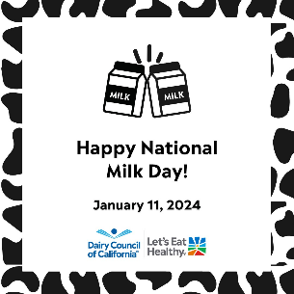  *Or post a photo of your celebration!
Facebook/Instagram | #DYK it only takes two days for milk to get from the farm to your school or local grocery store?! This National Milk Day let's raise a glass to honor the hard work of our dedicated dairy farmers who ensure our access to nutritious and delicious milk!  Learn more at: HealthyEating.org/NationalMilkDay  #NationalMilkDay #LetsEatHealthy | *Or post a photo of your celebration!
Dairy Council of California
National Milk Day
January 11, 2024

Sample Social Media Posts

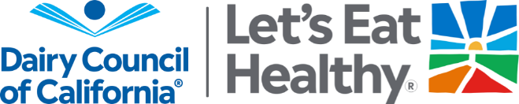
For your convenience, use these sample social posts to promote National Milk Day on your social channels. The downloadable image can accompany these posts, and we encourage you also to post photos from your celebrations! Be sure to tag @HealthyEatingCA and use the hashtags #NationalMilkDay and #LetsEatHealthy.

