Math word problem Answer Key

Grade: 4th & 5th

Common Core Standards:

Operations & Algebraic Thinking
CCSS.MATH.CONTENT.4.OA.A.2
Multiply or divide to solve word problems involving multiplicative comparison, e.g., by using drawings and equations with a symbol for the unknown number to represent the problem, distinguishing multiplicative comparison from additive comparison.

Measurement & Data
CCSS.MATH.CONTENT.4.MD.A.2
Use the four operations to solve word problems involving distances, intervals of time, liquid volumes, masses of objects, and money, including problems involving simple fractions or decimals, and problems that require expressing measurements given in a larger unit in terms of a smaller unit. Represent measurement quantities using diagrams such as number line diagrams that feature a measurement scale.

*Extension activity
To extend the activity and encourage more collaboration, creativity, and critical thinking have the students create their own problem and have a partner solve it.

Name: _________________________________

S-MOOOOOO-thie
Math word problem

The school food service staff at Sun Valley Elementary is trying to be creative and provide tasteful ways for students to meet their '3 out of 5' food requirement. The food service staff has developed a new recipe and would like the 4th and 5th grade classes to taste the recipe and provide their input.

The recipe is a fruit smoothie that contains:

Bananas, strawberries, 100% orange juice, old- fashioned rolled oats, and low fat yogurt.

The recipe makes 3 gallons of fruit smoothie.

The 4th grade class has 24 students and the 5th grade class has 27 students.

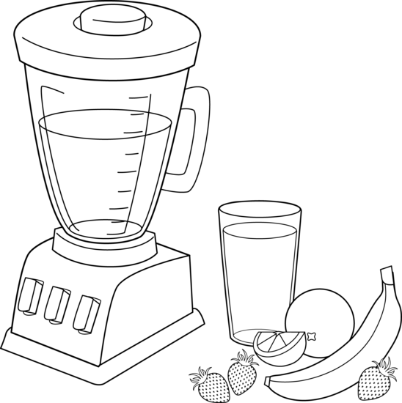
1 cup = 8 ounces
1 pint = 2 cups
1 quart = 2 pints
4 quarts = 1 gallon

- How many cups will this recipe make?

48 cups of smoothie

- Will there be enough smoothie for each 4th and 5th grade student to have 1 cup?

24 +27 = 51. No, there will not be enough smothie for both classes.

Show how you solved question A & B using the Read, Draw, Write (RDW) method. In other words, draw how you would solve the problem, write a number sentence, and use words to explain your thinking. Once you have finished share your solutions with a classmate.

Solution A

1 gallon

4 cups | 4 cups | 4 cups | 4 cups

1 qt. 1 qt. 1 qt. 1qt

4X4 cups= 16 cups
3X16 cups=48 cups

There will be 48 cups of smoothie

It takes 4 cups to equal 1 quart and 4 quarts to make 1 gallon. So, 3 times the number of cups will give you 48 cups of smoothie.

Solution B

Some students may need to use scaffolds to manage information- conversions rules for measurement units. In solution B students can use a four-column table to see the relationships between gallons, quarts, pints, and cups.

Gallons | Quarts | Pints | Cups
 |  | 1 | 2
 | 1 | 2 | 4
 |  | 3 | 6
1 | 4 | 8 | 16

One gallon equals 4 quarts and 4 quarts equals eight pints. If the recipe makes 3 gallons you would multiply 3 times 16 gallons which equals 48 cups.

